* **What are the functional requirements of a library management system?**
* Function Requirement
* The Librarian can:

1. Add Article New entries must be entered in database
2. Update Article Any changes in articles should be updated in Case of update

3. Delete Article Wrong entry must be removed from system

4. Inquiry Members Inquiry all current enrolled members to view their details

5. Inquiry: Issuance Inquiry of all database articles

6. Check out Article To issue any article must be checked out

7. Check In article After receiving any article system will reenter article by Checking

8. Inquiry waiting for approvals Librarian will generate all newly application which is in waiting list

9. Reserve Article This use case is used to reserve any book with the name of librarian, it can be pledged

10. Set user Permission From this user case Librarian can give permission

Data Flow Diagram

level - 0 DFD

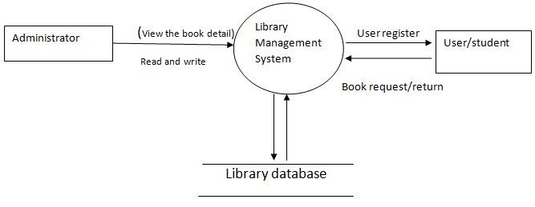

level - 1 D

